SETTER AND POINTER TRIAL ON GROUSE 13TH/14TH JULY 2016
By the kind permission of His Grace, The Duke of Northumberland the Club returned to Burncastle Estate. The ground lends itself favourably to our sport, the well-kept moor with sweeping hills means the game is excellent and the visibility is good. Our judges for the day, Mr Colin Organ and Mr Dave Amsden.

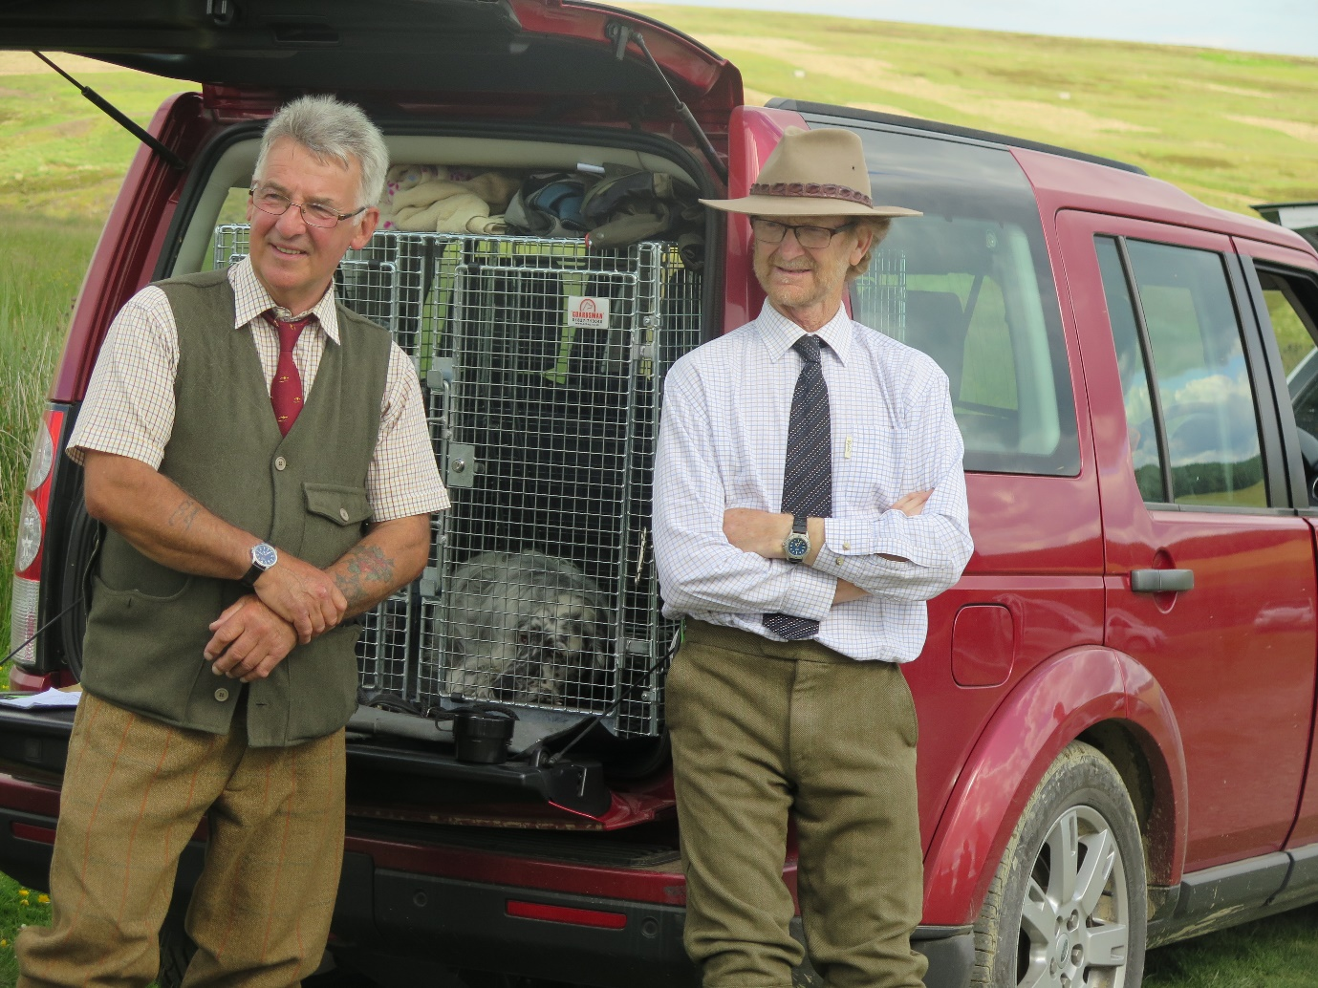

The first trip on the ground was for English setter Mariglen Mercedes, who was successful, at her first attempt at a SGWC, much to the delight of her handler Mrs Brenda Seaman.
Next, was the Puppy stake, made up of 6 pointers, an irish setter dog and a gordon setter bitch. Four were taken through to the second round and a very deserving first place was awarded to Mr Terry Smith’s, one year old pointer dog Fearn Stanley handled by Mr Allan Neill. A certificate of merit awarded to Mrs Tilly Thomas’ GSB Chartan Treacle Tart JW.
Our second stake of the day was a Novice, withdrawals, then late entries made the stake up to the 12 required for a qualifying stake. As with the puppies, many had not been on the hill to experience birds this season and just two brace went through. Having settled to her job after a COM in the Puppy stake, Chartan Treacle Tart, showed her skills, came out on top and was awarded 1st place. No other awards were given.
On the second day sunshine greeted the judges, keepers and competitors, and the temperatures rose as the day progressed. Thirty five dogs ran in the first round, including a pointer and gordon setter which had travelled from Switzerland with their handlers. Six brace were successful and made it through to the second round, with three brace taken for further decisions to be made in the third . After a very exciting trial, showing some excellent dog work the awards were made to: - 1st Mr. Hild’s PB Ardclinis Eva of Gerensary, handled by Mr Richard MacNicol, 2nd Mr D Goutorbe’s ESB Upperwood Clover, 3rd Mr D Goutorbe’s ESD F.T. Ch. Upperwood Forest, and 4th Mr R MacNicol’s PB Gerensary Zita. Certificates of Merit to Mr. Michel’s PD Deeverspring Angus. Mr B Morris’ ISD Erinvale Mission, Mr D Goutorbe’s ESB F.T.Ch Upperwood Hera and F.T. Ch. Gibeltarik Troy of Upperwood.
The Open stake winner thanks our host, the estate and judges for a fabulous two days.

